Ratio Equality
# Source: AI Source: Provided by: [Data Path: Persons Table -> ID Column: 1, Name_En Column: Motasem Essam] -> From: [ChatGPT] on [7/25/2026]
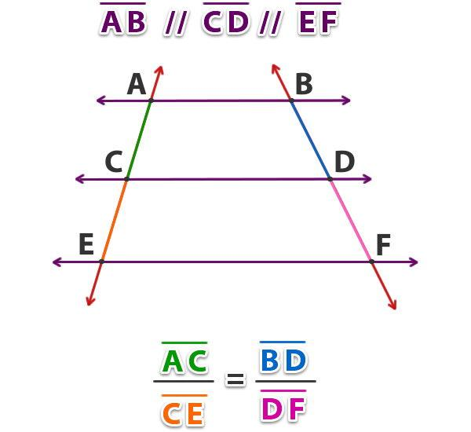
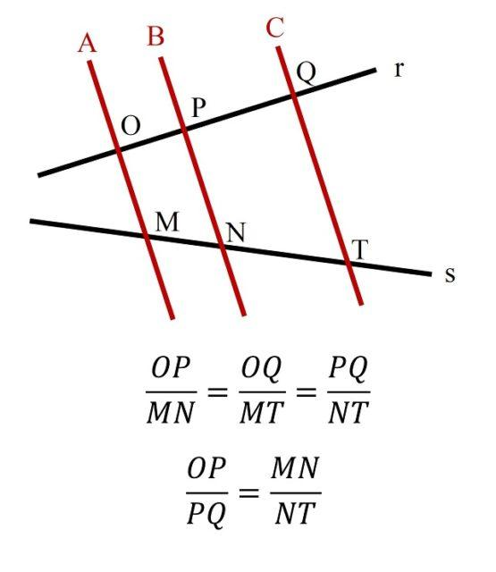
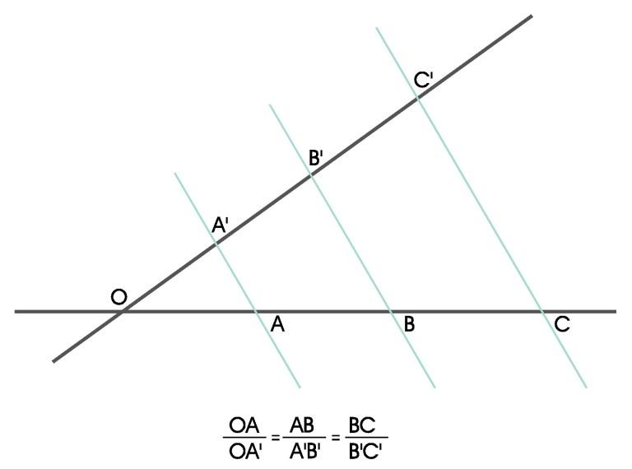
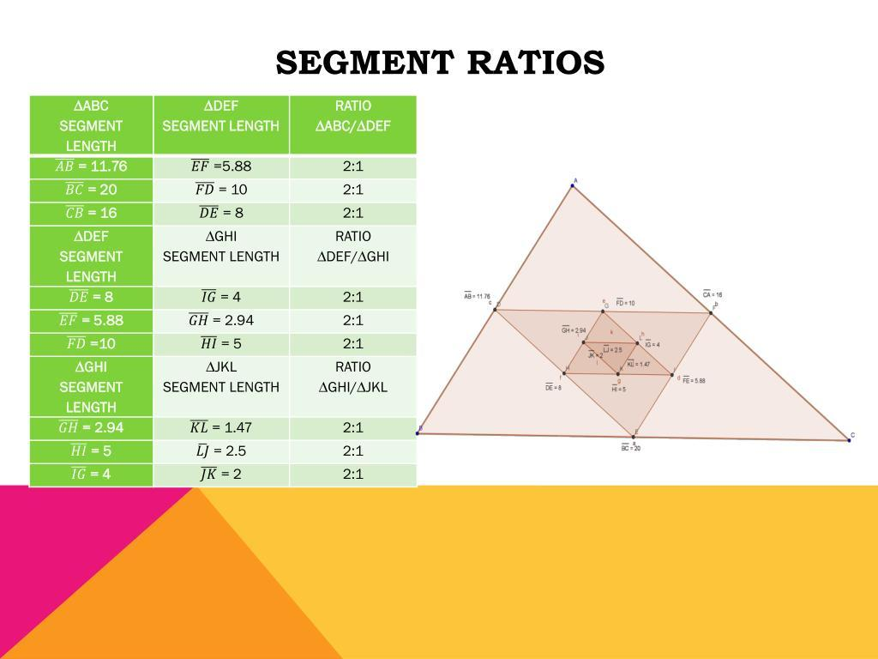
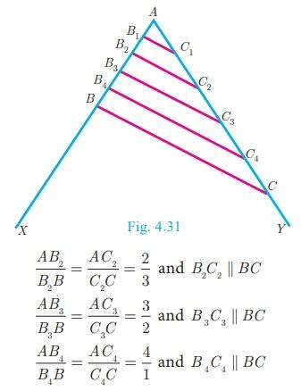

Definition
# Source: AI Source: Provided by: [Data Path: Persons Table -> ID Column: 1, Name_En Column: Motasem Essam] -> From: [ChatGPT] on [7/25/2026]
Ratio Equality is an exact geometric relationship in which two or more ratios of geometric quantities are equal.
For example:
$$\boxed{\frac{AB}{BC}=\frac{DE}{EF}}$$
This means that the relationship between $AB$and $BC$is exactly the same as the relationship between $DE$and $EF$.

Simple Definition
# Source: AI Source: Provided by: [Data Path: Persons Table -> ID Column: 1, Name_En Column: Motasem Essam] -> From: [ChatGPT] on [7/25/2026]
Ratio Equality means that two or more geometric ratios have exactly the same value.
For example:
$$\frac{AB}{BC}=\frac{2}{3}$$
and:
$$\frac{DE}{EF}=\frac{2}{3}.$$
Therefore:
$$\boxed{\frac{AB}{BC}=\frac{DE}{EF}}.$$

Fundamental Concept
# Source: AI Source: Provided by: [Data Path: Persons Table -> ID Column: 1, Name_En Column: Motasem Essam] -> From: [ChatGPT] on [7/25/2026]
A ratio compares two quantities by division.
For two geometric quantities $A$and $B$:
$$\boxed{\frac{A}{B}}$$
is their ratio, provided $B≠0$.
Ratio Equality occurs when:
$$\boxed{\frac{A}{B}=\frac{C}{D}}$$
with $B,D≠0$.
An equivalent form is:
$$\boxed{AD=BC}$$
provided the denominators are nonzero.
Example
$$\frac{6}{9}=\frac{8}{12}.$$
Cross-multiplication gives:
$$6\left(12\right)=9\left(8\right) \\ 72=72.$$
Therefore the ratios are equal.

Ratio Equality in Geometry
# Source: AI Source: Provided by: [Data Path: Persons Table -> ID Column: 1, Name_En Column: Motasem Essam] -> From: [ChatGPT] on [7/25/2026]
Ratio Equality can compare many geometric quantities:
- segment lengths
- distances
- sides of triangles
- corresponding sides of similar figures
- areas
- perimeters
- radii
- diameters
- coordinates
- corresponding dimensions of scaled figures
For example:
$$\frac{AB}{BC}=\frac{AC}{CD}$$
or:
$$\frac{A_{1}}{A_{2}}=\frac{B_{1}}{B_{2}}.$$

Classification of Ratio Equality
# Source: AI Source: Provided by: [Data Path: Persons Table -> ID Column: 1, Name_En Column: Motasem Essam] -> From: [ChatGPT] on [7/25/2026]
A practical classification is:
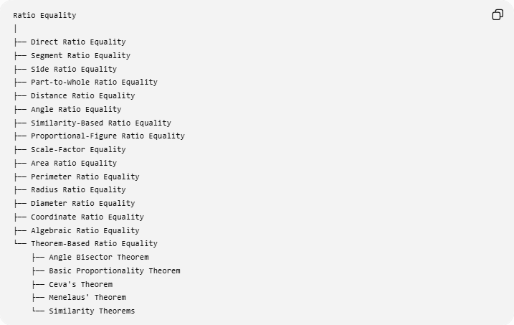
Ratio Equality
│
├── Direct Ratio Equality
├── Segment Ratio Equality
├── Side Ratio Equality
├── Part-to-Whole Ratio Equality
├── Distance Ratio Equality
├── Angle Ratio Equality
├── Similarity-Based Ratio Equality
├── Proportional-Figure Ratio Equality
├── Scale-Factor Equality
├── Area Ratio Equality
├── Perimeter Ratio Equality
├── Radius Ratio Equality
├── Diameter Ratio Equality
├── Coordinate Ratio Equality
├── Algebraic Ratio Equality
└── Theorem-Based Ratio Equality
├── Angle Bisector Theorem
├── Basic Proportionality Theorem
├── Ceva's Theorem
├── Menelaus' Theorem
└── Similarity Theorems
This is a practical classification, not a universally standardized formal taxonomy.

Direct Ratio Equality
# Source: AI Source: Provided by: [Data Path: Persons Table -> ID Column: 1, Name_En Column: Motasem Essam] -> From: [ChatGPT] on [7/25/2026]
Definition
The equality is directly given:
$$\boxed{\frac{AB}{BC}=\frac{DE}{EF}}$$
Example
Suppose:
$$AB=4, BC=6$$
and:
$$DE=8, EF=12.$$
Then:
$$\frac{AB}{BC}=\frac{4}{6}=\frac{2}{3}$$
and:
$$\frac{DE}{EF}=\frac{8}{12}=\frac{2}{3}.$$
Therefore:
$$\boxed{\frac{AB}{BC}=\frac{DE}{EF}}.$$

Segment Ratio Equality
# Source: AI Source: Provided by: [Data Path: Persons Table -> ID Column: 1, Name_En Column: Motasem Essam] -> From: [ChatGPT] on [7/25/2026]
Definition
Segment Ratio Equality compares ratios formed from line-segment lengths.
For example:
$$\boxed{\frac{AB}{BC}=\frac{DE}{EF}}.$$
Example
On one line:
$$AB=5, BC=10.$$
On another:
$$DE=7, EF=14.$$
Then:
$$\frac{AB}{BC}=\frac{5}{10}=\frac{1}{2}$$
and:
$$\frac{DE}{EF}=\frac{7}{14}=\frac{1}{2}.$$
Therefore:
$$\boxed{\frac{AB}{BC}=\frac{DE}{EF}}.$$
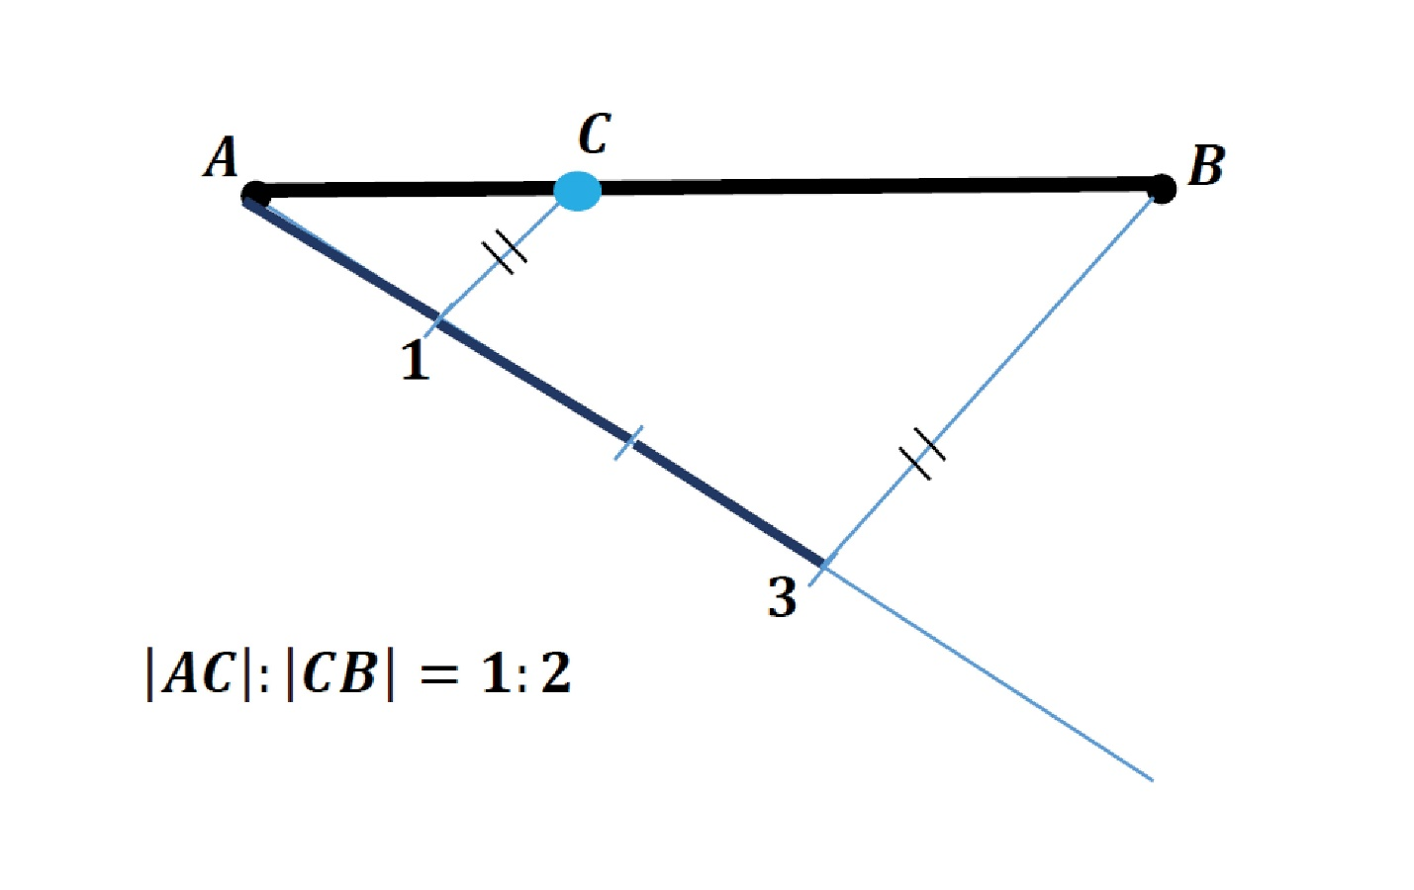
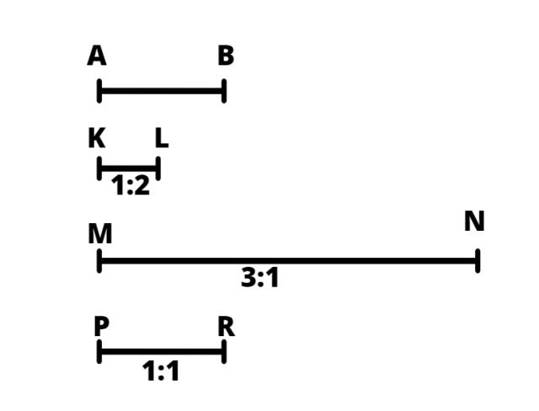
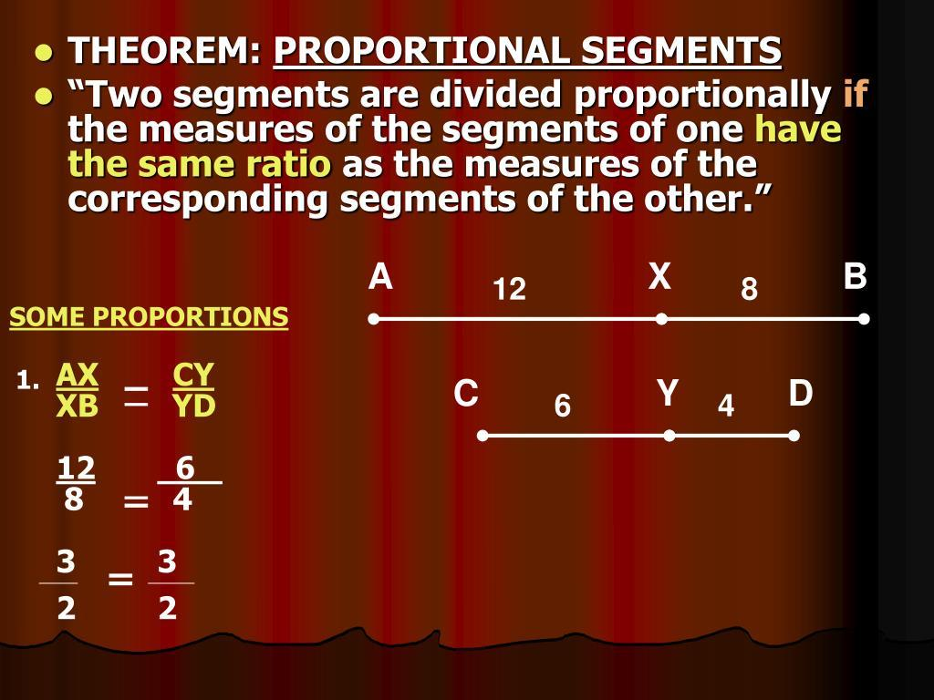
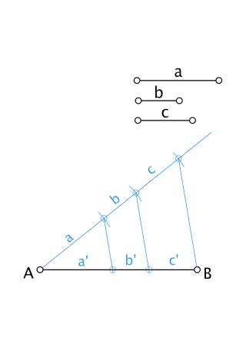
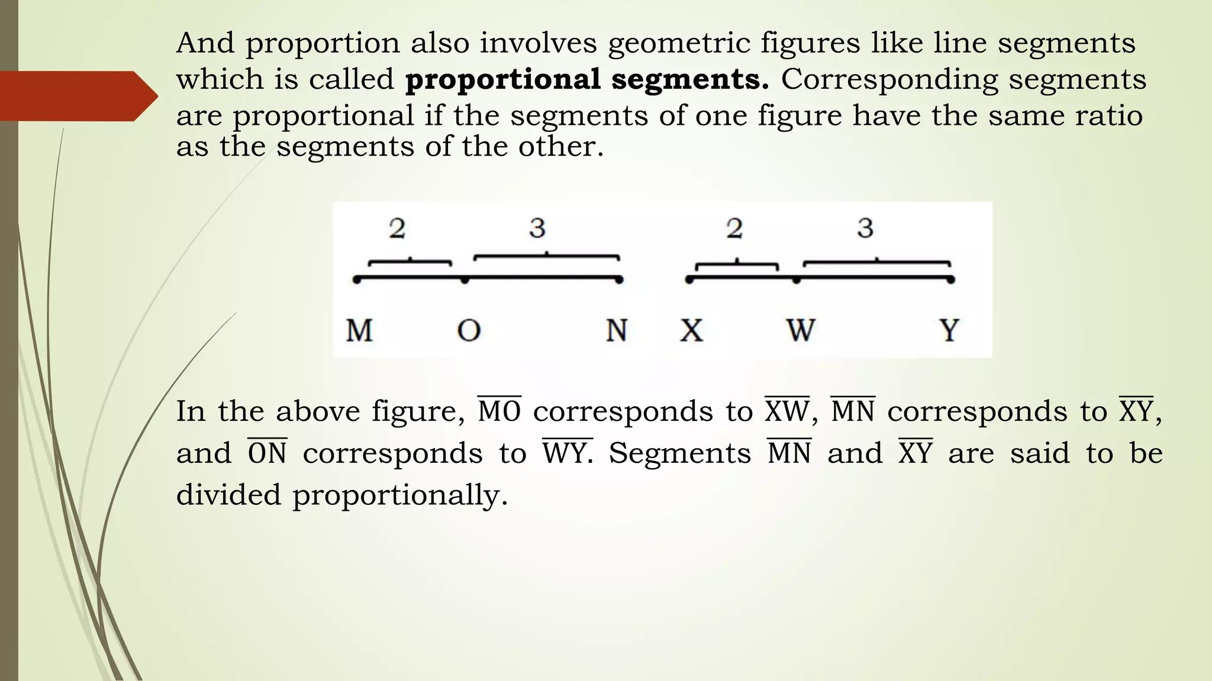

Side Ratio Equality
# Source: AI Source: Provided by: [Data Path: Persons Table -> ID Column: 1, Name_En Column: Motasem Essam] -> From: [ChatGPT] on [7/25/2026]
Definition
Side Ratio Equality occurs when ratios between sides of geometric figures are equal.
For triangles:
$$\boxed{\frac{AB}{AC}=\frac{DE}{DF}}$$
Example
Triangle 1:
$$AB=6, AC=9.$$
Triangle 2:
$$DE=8, DF=12.$$
Then:
$$\frac{AB}{AC}=\frac{6}{9}=\frac{2}{3}$$
and:
$$\frac{DE}{DF}=\frac{8}{12}=\frac{2}{3}.$$
Thus:
$$\boxed{\frac{AB}{AC}=\frac{DE}{DF}}.$$

Part-to-Whole Ratio Equality
# Source: AI Source: Provided by: [Data Path: Persons Table -> ID Column: 1, Name_En Column: Motasem Essam] -> From: [ChatGPT] on [7/25/2026]
A ratio can compare a part of a figure to the whole figure.
Example
Suppose a segment has total length:
$$AB=15$$
and:
$$AC=5.$$
Then:
$$\frac{AC}{AB}=\frac{5}{15}=\frac{1}{3}.$$
If another segment has:
$$DE=21, DF=7,$$
then:
$$\frac{DF}{DE}=\frac{7}{21}=\frac{1}{3}.$$
Therefore:
$$\boxed{\frac{AC}{AB}=\frac{DF}{DE}}.$$
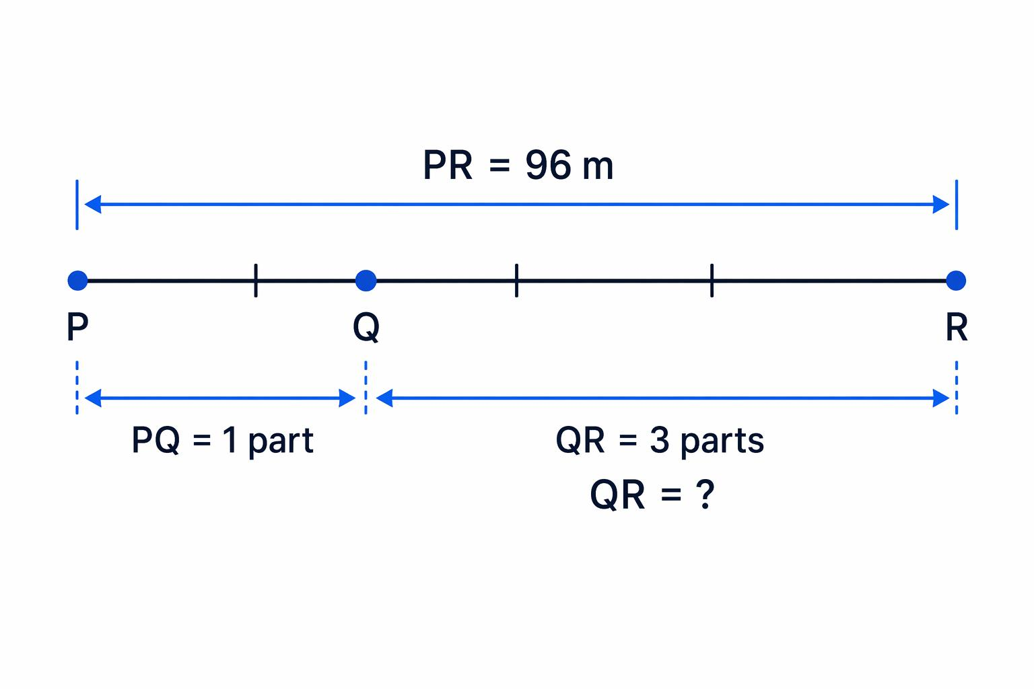
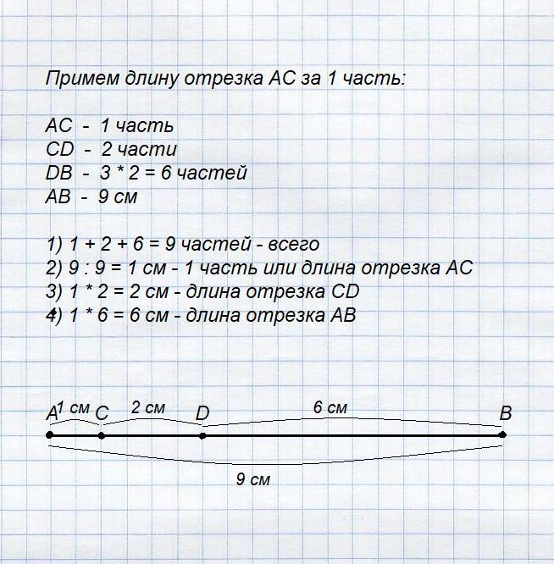
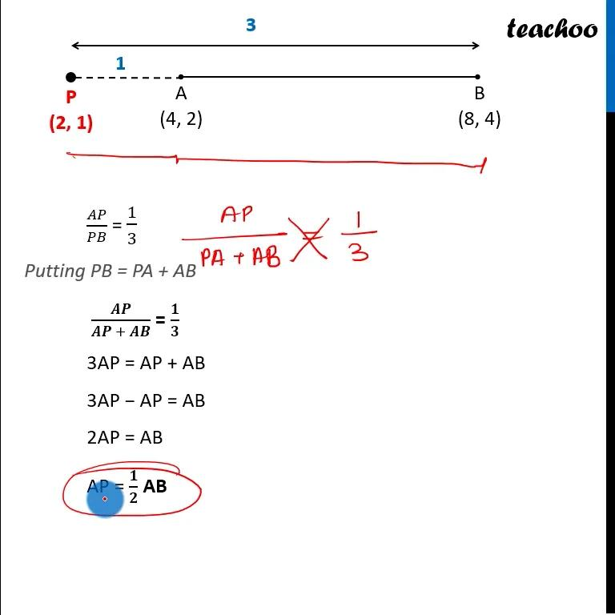
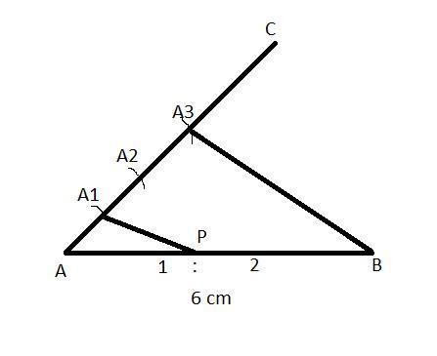

Distance Ratio Equality
# Source: AI Source: Provided by: [Data Path: Persons Table -> ID Column: 1, Name_En Column: Motasem Essam] -> From: [ChatGPT] on [7/25/2026]
Distances between geometric objects can also form equal ratios.
For example:
$$\boxed{\frac{PA}{PB}=\frac{QC}{QD}}$$
Example
$$PA=4, PB=8$$
and:
$$QC=6, QD=12.$$
Then:
$$\frac{PA}{PB}=\frac{4}{8}=\frac{1}{2}$$
and:
$$\frac{QC}{QD}=\frac{6}{12}=\frac{1}{2}.$$
Therefore:
$$\boxed{\frac{PA}{PB}=\frac{QC}{QD}}.$$

Angle Ratio Equality
# Source: AI Source: Provided by: [Data Path: Persons Table -> ID Column: 1, Name_En Column: Motasem Essam] -> From: [ChatGPT] on [7/25/2026]
Angle measures can also be compared using ratios.
For example:
$$\boxed{\frac{m∠A}{m∠B}=\frac{m∠C}{m∠D}}$$
Example
$$m∠A={30}^{∘}, m∠B={60}^{∘}$$
and:
$$m∠C={40}^{∘}, m∠D={80}^{∘}.$$
Then:
$$\frac{30}{60}=\frac{1}{2}$$
and:
$$\frac{40}{80}=\frac{1}{2}.$$
Therefore:
$$\boxed{\frac{m∠A}{m∠B}=\frac{m∠C}{m∠D}}$$
Important
Angle Ratio Equality is different from Angle Equality.
$$m∠A=m∠B$$
means the angles have the same measure.
But:
$$\frac{m∠A}{m∠B}=\frac{1}{2}$$
means their measures have a $1:2$relationship.

Similarity-Based Ratio Equality
# Source: AI Source: Provided by: [Data Path: Persons Table -> ID Column: 1, Name_En Column: Motasem Essam] -> From: [ChatGPT] on [7/25/2026]
This is one of the most important applications of Ratio Equality.
If:
$$△ABC∼△DEF,$$
then corresponding sides are proportional:
$$\boxed{\frac{AB}{DE}=\frac{BC}{EF}=\frac{AC}{DF}}$$
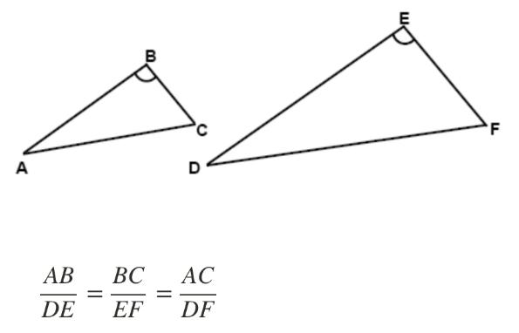
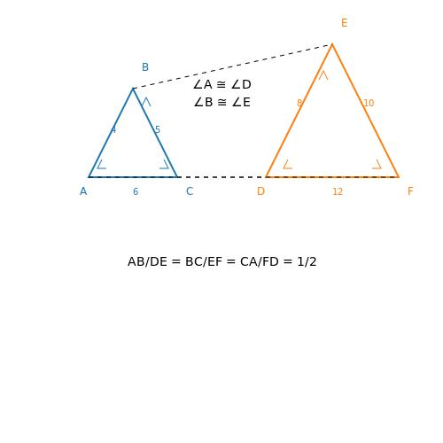
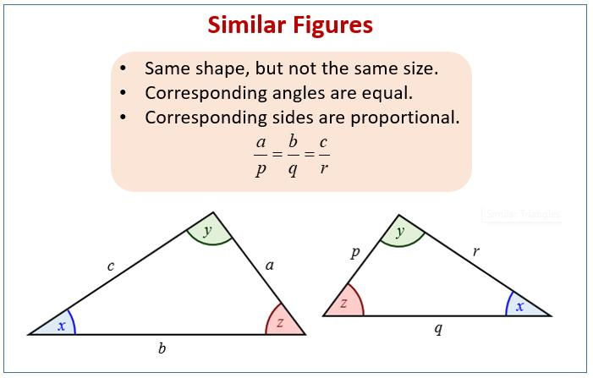
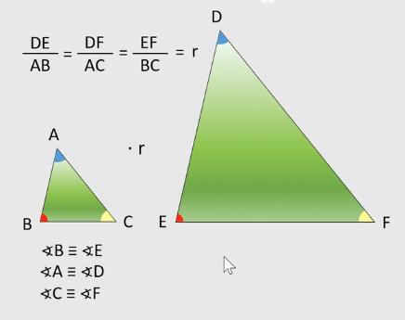
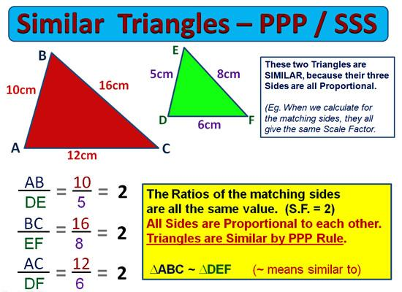
Example
Suppose:
$$AB=6, BC=8, AC=10$$
and:
$$DE=9, EF=12, DF=15.$$
Then:
$$\frac{AB}{DE}=\frac{6}{9}=\frac{2}{3} \\ \frac{BC}{EF}=\frac{8}{12}=\frac{2}{3} \\ \frac{AC}{DF}=\frac{10}{15}=\frac{2}{3}.$$
Therefore:
$$\boxed{\frac{AB}{DE}=\frac{BC}{EF}=\frac{AC}{DF}=\frac{2}{3}}$$

Proportional-Figure Ratio Equality
# Source: AI Source: Provided by: [Data Path: Persons Table -> ID Column: 1, Name_En Column: Motasem Essam] -> From: [ChatGPT] on [7/25/2026]
Similar figures have proportional corresponding dimensions.
For example, two rectangles can satisfy:
$$\boxed{\frac{l_{1}}{l_{2}}=\frac{w_{1}}{w_{2}}}$$
Example
Rectangle A:
$$l_{1}=12, w_{1}=8.$$
Rectangle B:
$$l_{2}=18, w_{2}=12.$$
Then:
$$\frac{12}{18}=\frac{2}{3}$$
and:
$$\frac{8}{12}=\frac{2}{3}.$$
Therefore:
$$\boxed{\frac{l_{1}}{l_{2}}=\frac{w_{1}}{w_{2}}}.$$
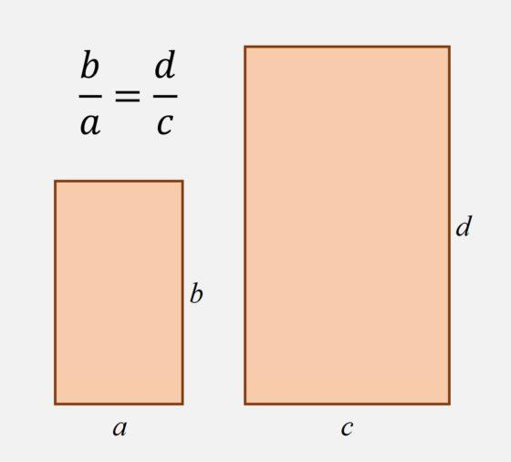
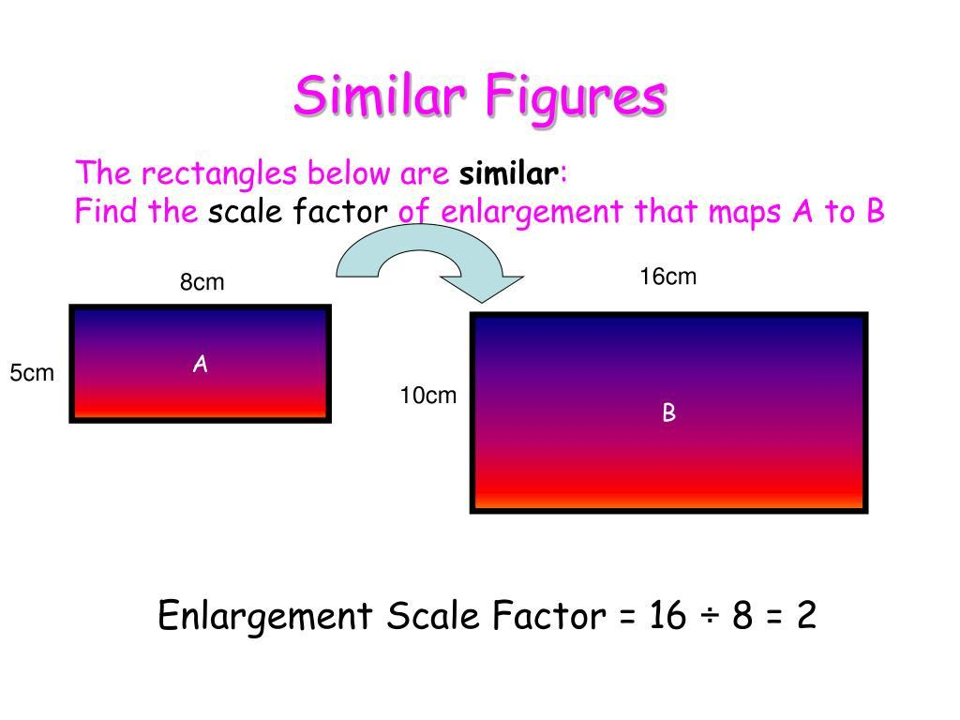
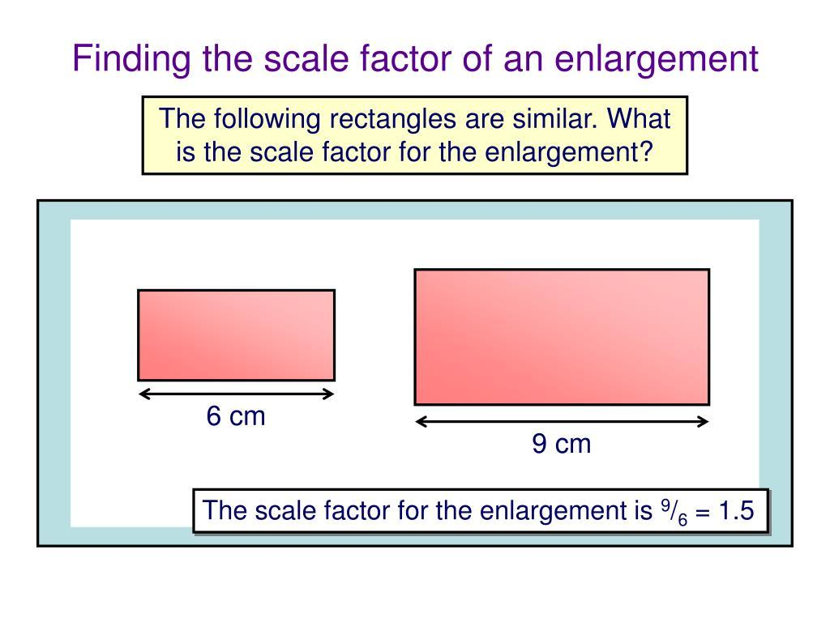
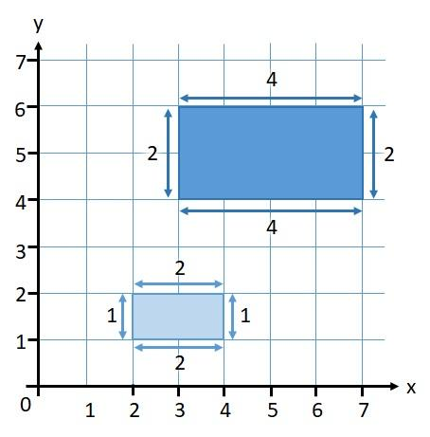
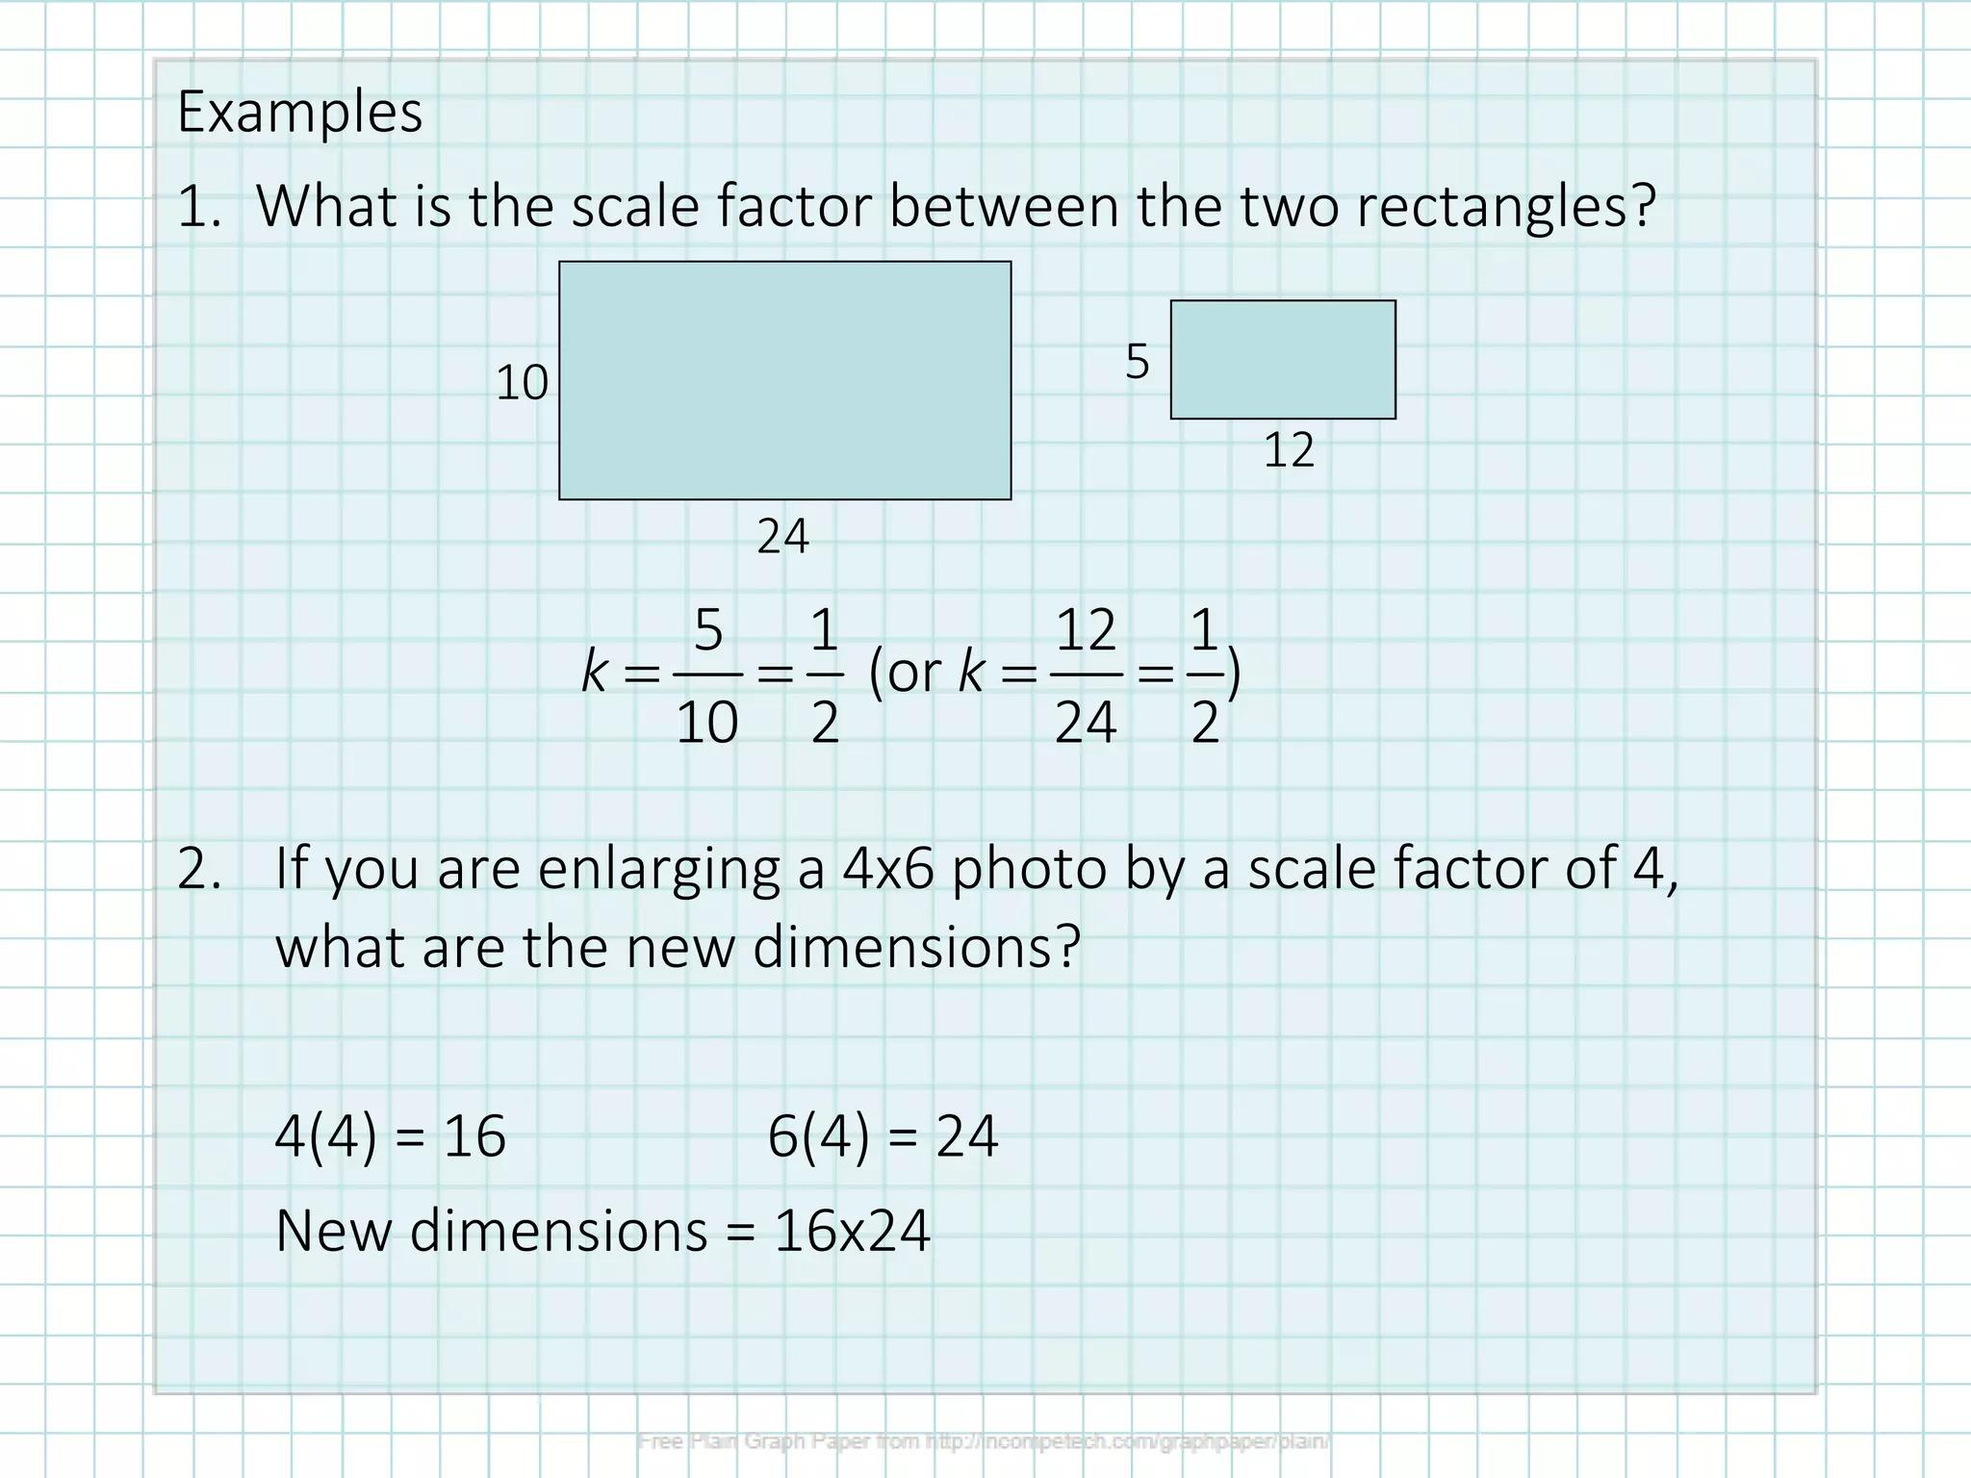

Scale-Factor Equality
# Source: AI Source: Provided by: [Data Path: Persons Table -> ID Column: 1, Name_En Column: Motasem Essam] -> From: [ChatGPT] on [7/25/2026]
The scale factor is the common ratio between corresponding lengths.
If:
$$△ABC∼△DEF,$$
then:
$$\boxed{k=\frac{DE}{AB}=\frac{EF}{BC}=\frac{DF}{AC}}$$
Example
If:
$$AB=5, DE=10,$$
then:
$$k=\frac{10}{5}=2.$$
If:
$$BC=7,$$
the corresponding side is:
$$EF=14.$$
Therefore:
$$\frac{DE}{AB}=\frac{EF}{BC}=2.$$

Area Ratio Equality
# Source: AI Source: Provided by: [Data Path: Persons Table -> ID Column: 1, Name_En Column: Motasem Essam] -> From: [ChatGPT] on [7/25/2026]
Areas can also form equal ratios.
For similar figures with linear scale factor $k$:
$$\boxed{\frac{A_{2}}{A_{1}}=k^{2}}$$
Example
Two similar squares have side lengths:
$$4\text{ cm}$$
and:
$$8\text{ cm}.$$
The linear ratio is:
$$\frac{8}{4}=2.$$
The area ratio is:
$$\frac{8^{2}}{4^{2}}=\frac{64}{16}=4.$$
Therefore:
$$\boxed{\frac{A_{2}}{A_{1}}=4}.$$
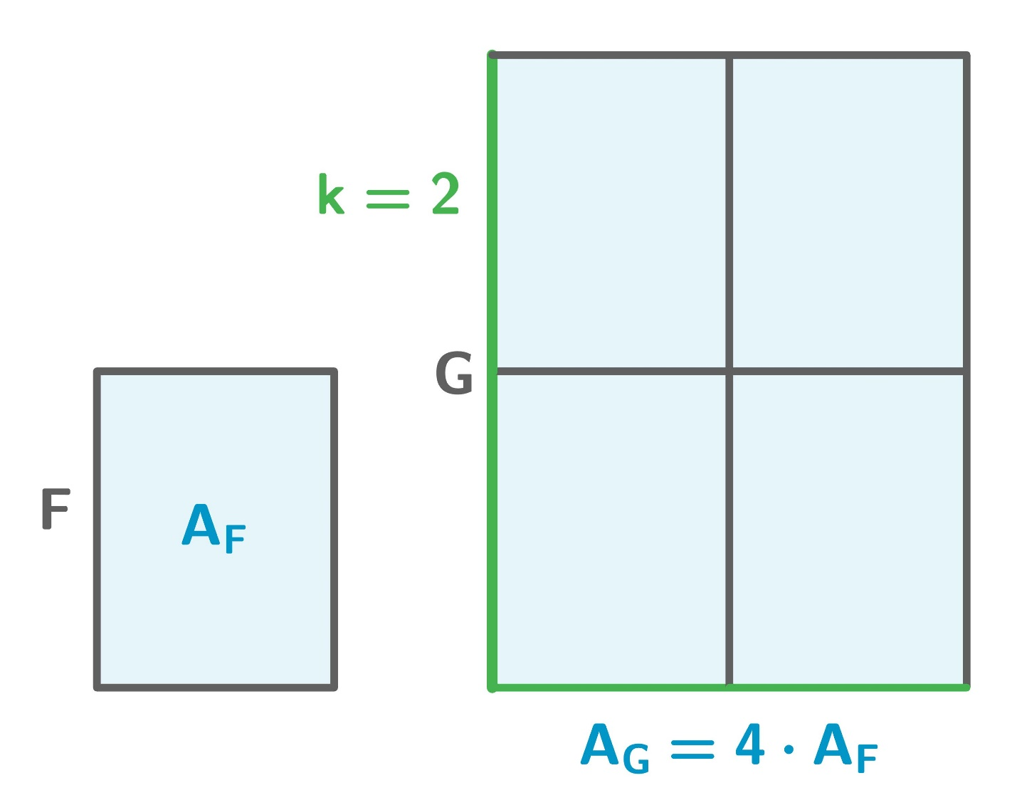
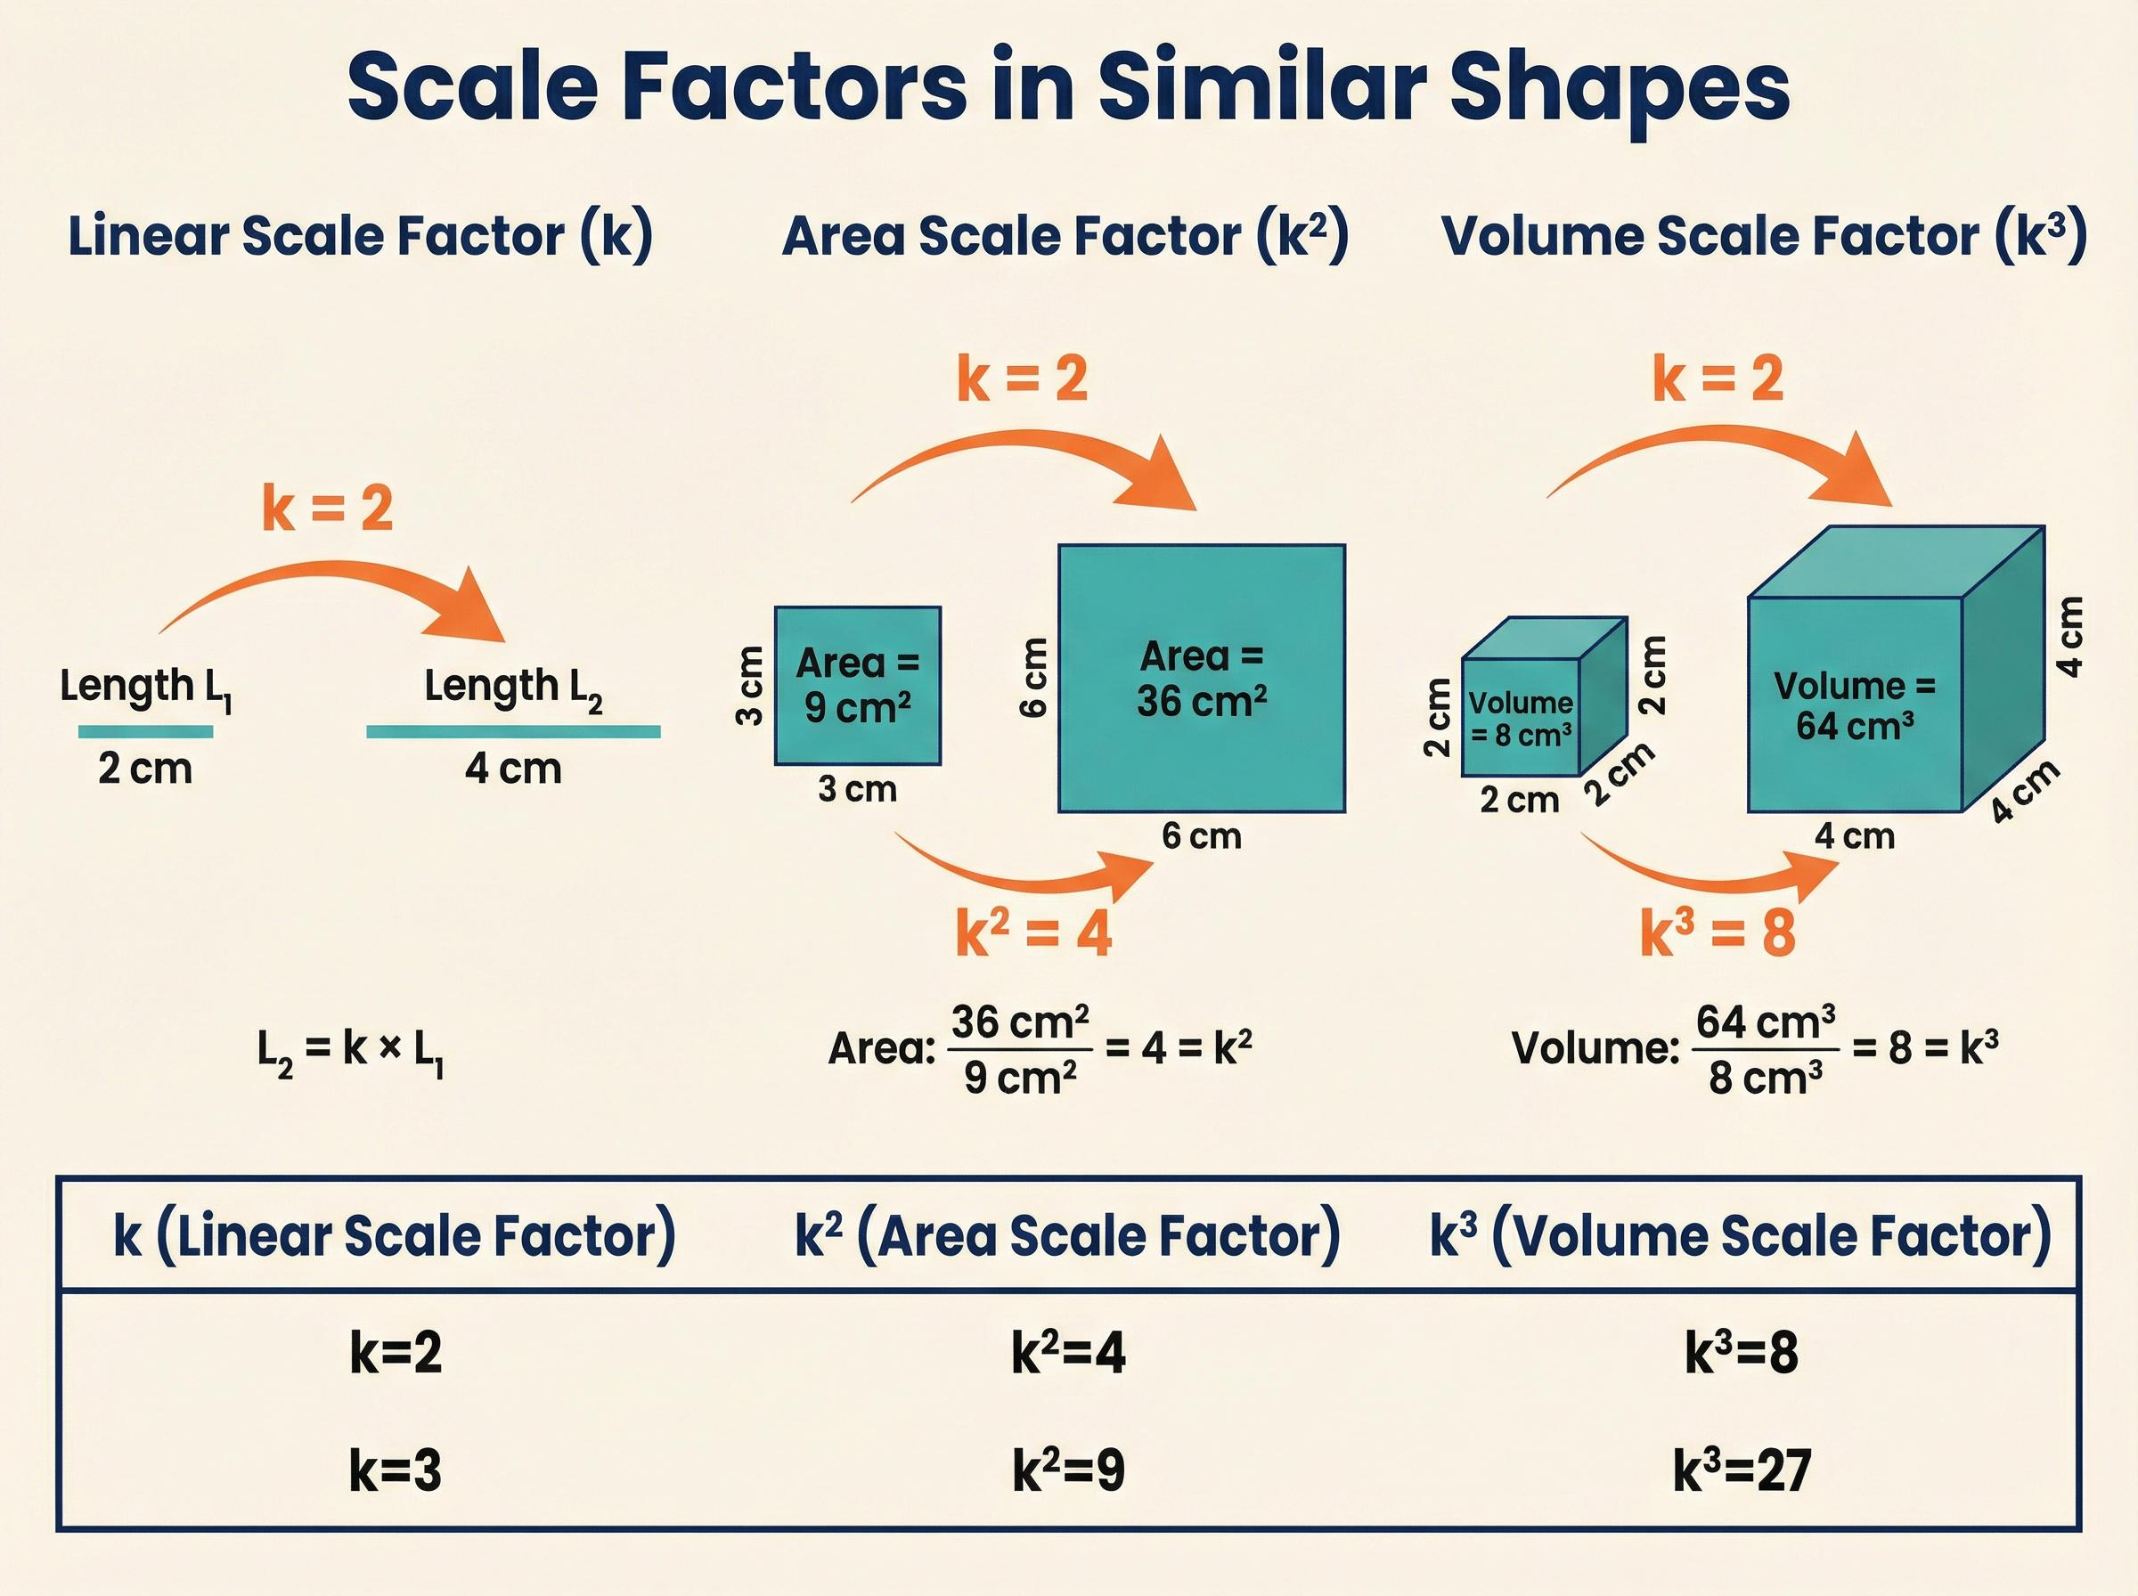
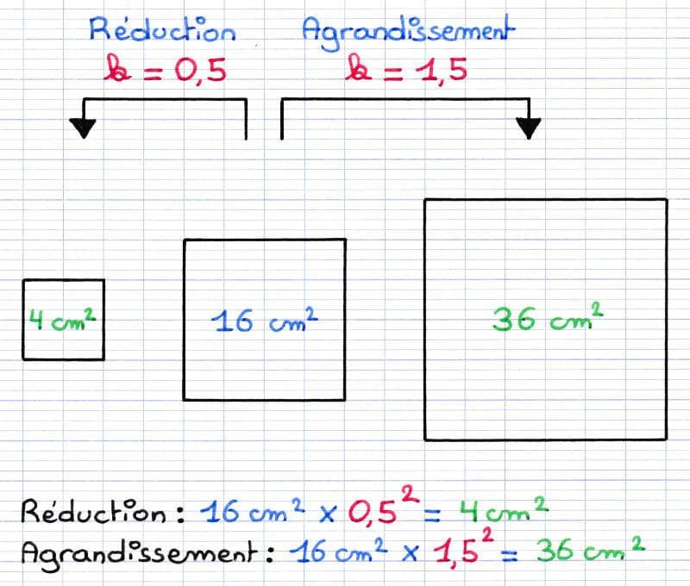
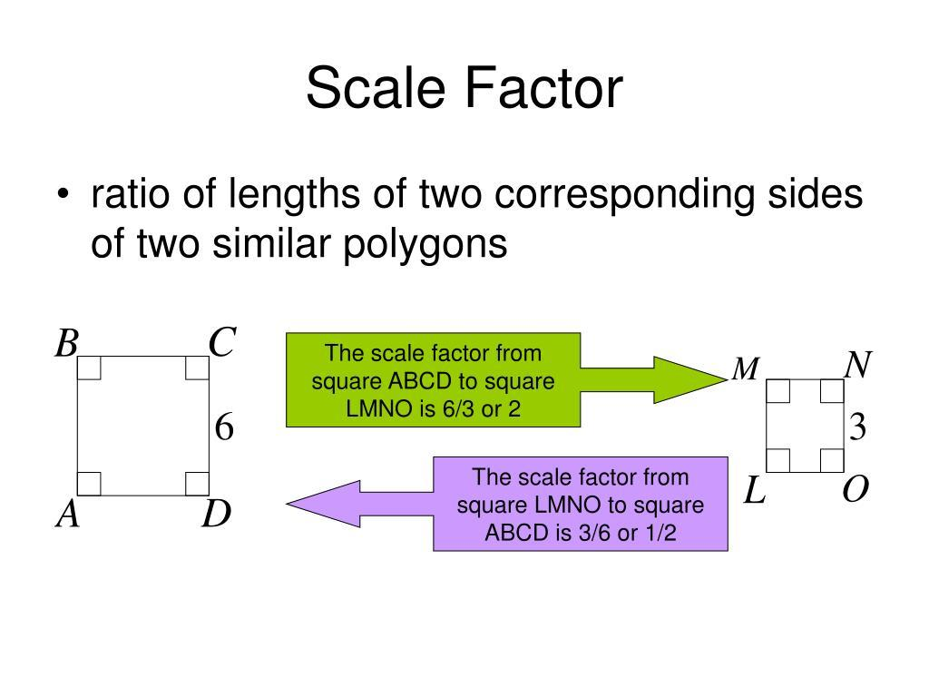
Important
For similar figures:
$$\boxed{\text{Length Ratio}=k}$$
but:
$$\boxed{\text{Area Ratio}=k^{2}}.$$

Perimeter Ratio Equality
# Source: AI Source: Provided by: [Data Path: Persons Table -> ID Column: 1, Name_En Column: Motasem Essam] -> From: [ChatGPT] on [7/25/2026]
For similar figures, corresponding perimeters have the same ratio as corresponding lengths:
$$\boxed{\frac{P_{2}}{P_{1}}=k}$$
Example
Two similar rectangles have scale factor:
$$k=3.$$
If:
$$P_{1}=20,$$
then:
$$P_{2}=60.$$
Thus:
$$\boxed{\frac{P_{2}}{P_{1}}=3}.$$

Radius Ratio Equality
# Source: AI Source: Provided by: [Data Path: Persons Table -> ID Column: 1, Name_En Column: Motasem Essam] -> From: [ChatGPT] on [7/25/2026]
For circles, radii can form a ratio:
$$\boxed{\frac{r_{1}}{r_{2}}}$$
Example
Two circles have:
$$r_{1}=6, r_{2}=9.$$
Then:
$$\frac{r_{1}}{r_{2}}=\frac{6}{9}=\frac{2}{3}.$$
If another pair of circles has:
$$r_{3}=8, r_{4}=12,$$
then:
$$\frac{r_{3}}{r_{4}}=\frac{8}{12}=\frac{2}{3}.$$
Therefore:
$$\boxed{\frac{r_{1}}{r_{2}}=\frac{r_{3}}{r_{4}}}.$$
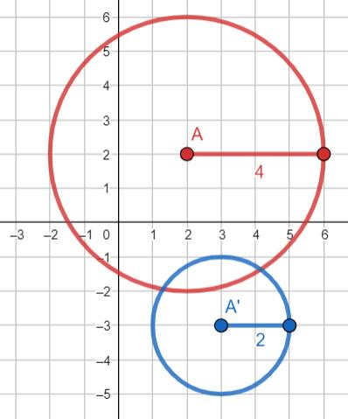
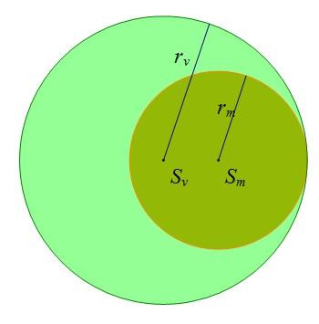
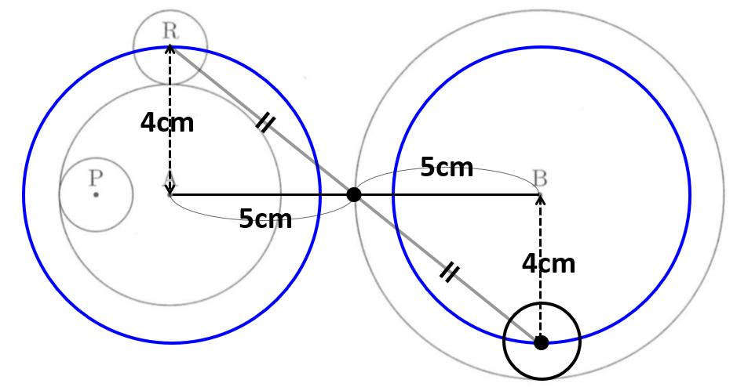

Diameter Ratio Equality
# Source: AI Source: Provided by: [Data Path: Persons Table -> ID Column: 1, Name_En Column: Motasem Essam] -> From: [ChatGPT] on [7/25/2026]
Because:
$$d=2r,$$
diameters have the same ratio as their corresponding radii:
$$\boxed{\frac{d_{1}}{d_{2}}=\frac{r_{1}}{r_{2}}}$$
Example
If:
$$r_{1}=4, r_{2}=6,$$
then:
$$\frac{r_{1}}{r_{2}}=\frac{4}{6}=\frac{2}{3}.$$
Their diameters are:
$$d_{1}=8, d_{2}=12,$$
so:
$$\frac{d_{1}}{d_{2}}=\frac{8}{12}=\frac{2}{3}.$$

Ratio Equality from the Angle Bisector Theorem
# Source: AI Source: Provided by: [Data Path: Persons Table -> ID Column: 1, Name_En Column: Motasem Essam] -> From: [ChatGPT] on [7/25/2026]
The Angle Bisector Theorem provides an important geometric ratio:
If $AD$bisects $∠A$in $△ABC$, then:
$$\boxed{\frac{BD}{DC}=\frac{AB}{AC}}$$
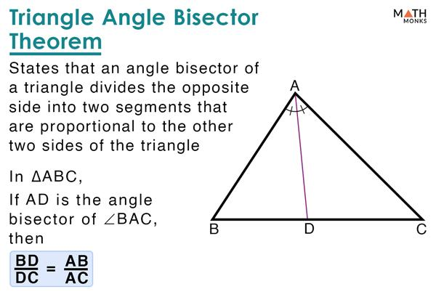
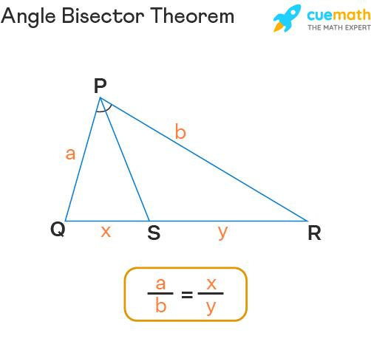
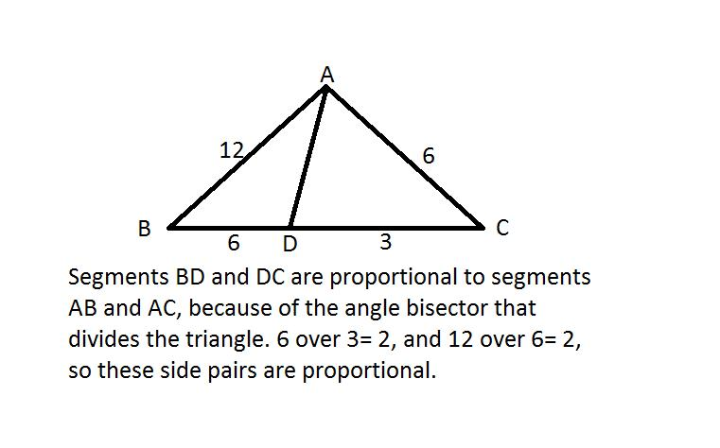
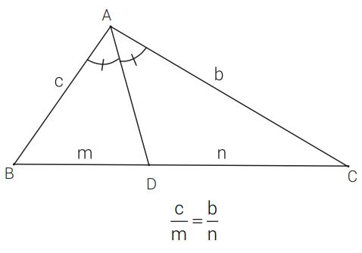
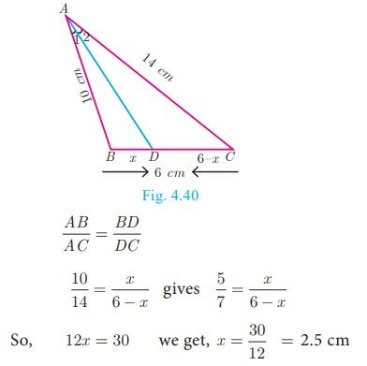
Example
Suppose:
$$AB=6, AC=9.$$
Then:
$$\frac{BD}{DC}=\frac{6}{9}=\frac{2}{3}.$$
If:
$$BD=4,$$
then:
$$\frac{4}{DC}=\frac{2}{3}.$$
Therefore:
$$3\left(4\right)=2\left(DC\right) \\ DC=6.$$
So:
$$\boxed{BD:DC=2:3}.$$

Ratio Equality from the Basic Proportionality Theorem
# Source: AI Source: Provided by: [Data Path: Persons Table -> ID Column: 1, Name_En Column: Motasem Essam] -> From: [ChatGPT] on [7/25/2026]
If a line is parallel to one side of a triangle, it divides the other two sides proportionally.
If:
$$DE∥BC,$$
then:
$$\boxed{\frac{AD}{DB}=\frac{AE}{EC}}$$
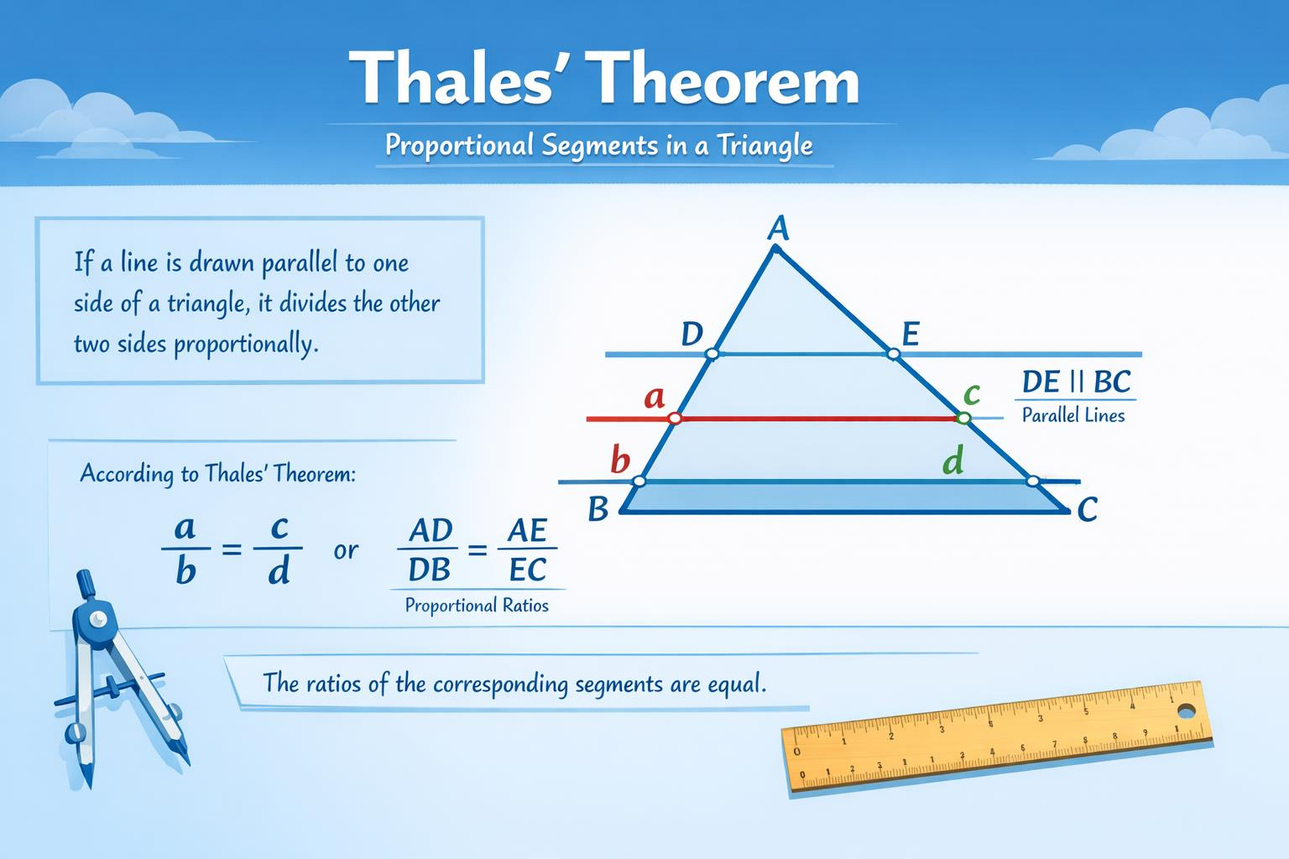
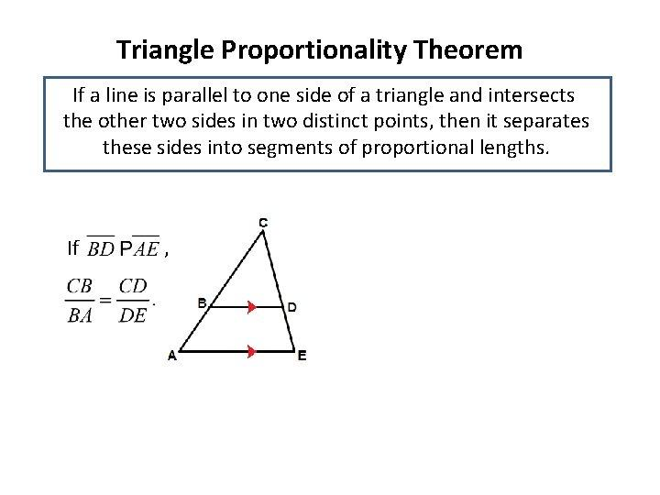
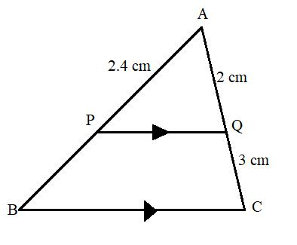
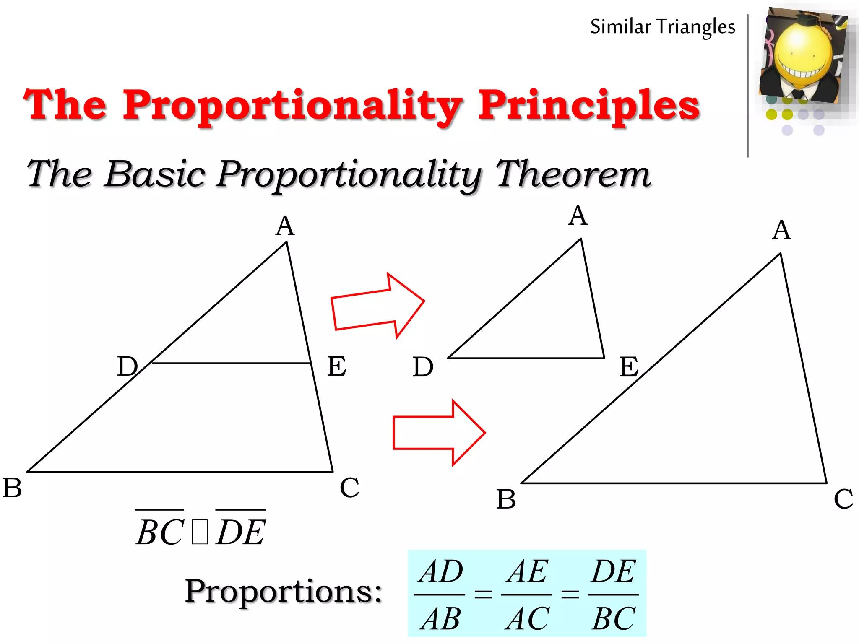
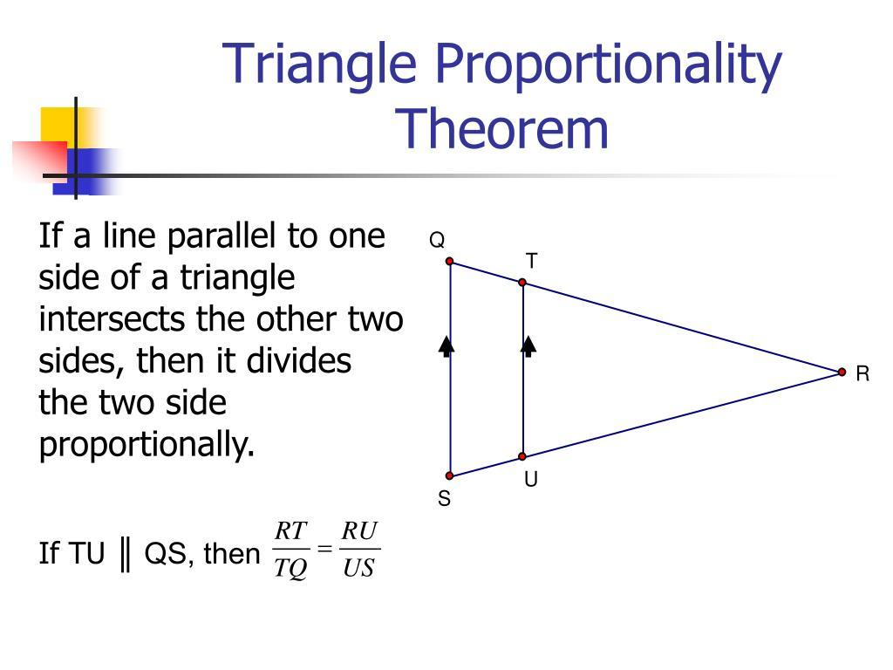
Example
If:
$$AD=4, DB=6,$$
then:
$$\frac{AD}{DB}=\frac{4}{6}=\frac{2}{3}.$$
Therefore:
$$\frac{AE}{EC}=\frac{2}{3}.$$
If $AE=8$, then:
$$\frac{8}{EC}=\frac{2}{3}$$
so:
$$EC=12.$$

Ratio Equality in Ceva's Theorem
# Source: AI Source: Provided by: [Data Path: Persons Table -> ID Column: 1, Name_En Column: Motasem Essam] -> From: [ChatGPT] on [7/25/2026]
For a triangle with cevians $AD,BE,CF$meeting the opposite sides:
$$\boxed{\frac{BD}{DC}\frac{CE}{EA}\frac{AF}{FB}=1}$$
This is a product of ratios rather than simply one ratio equal to another.
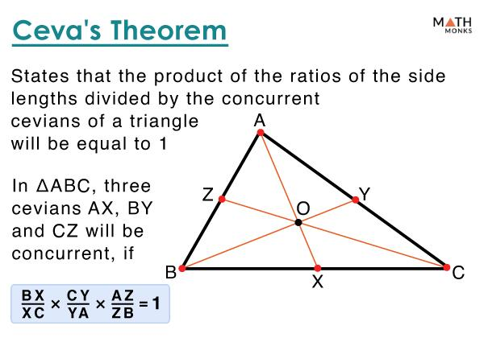
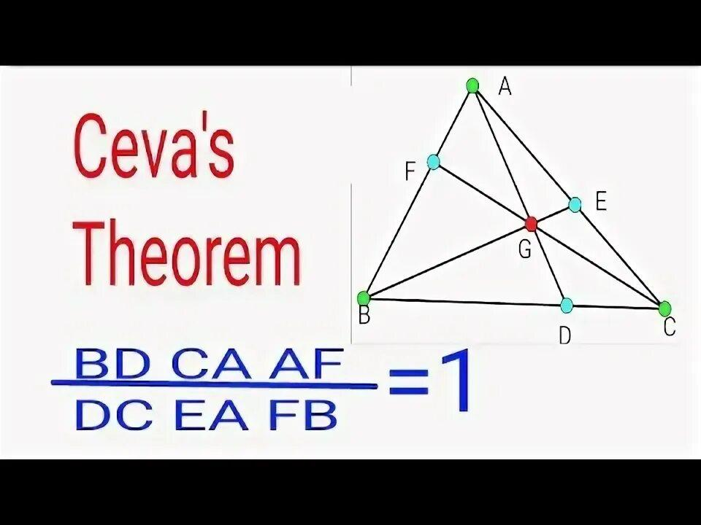
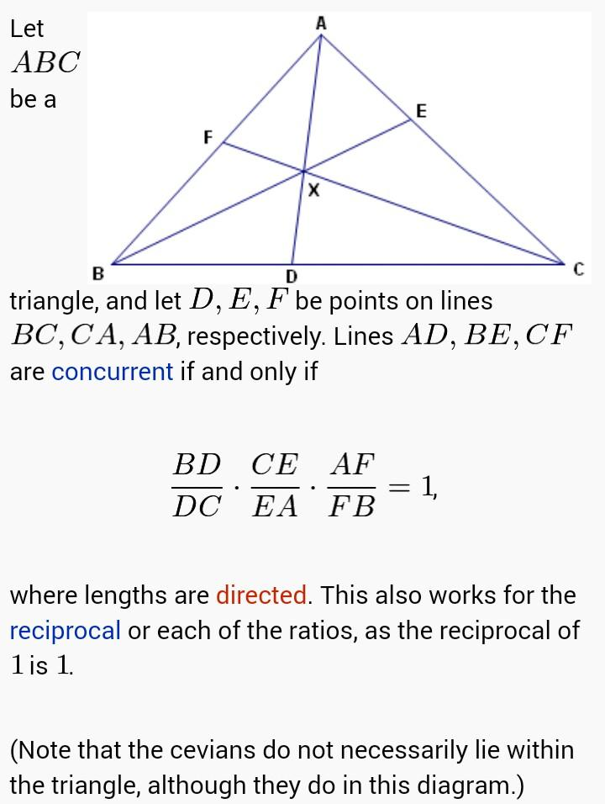
Example
Suppose:
$$\frac{BD}{DC}=2, \\ \frac{CE}{EA}=3,$$
and:
$$\frac{AF}{FB}=\frac{1}{6}.$$
Then:
$$2\left(3\right)\left(\frac{1}{6}\right)=1.$$
Therefore, the Ceva ratio condition is satisfied.

Ratio Equality in Menelaus' Theorem
# Source: AI Source: Provided by: [Data Path: Persons Table -> ID Column: 1, Name_En Column: Motasem Essam] -> From: [ChatGPT] on [7/25/2026]
For points $D,E,F$lying on the sides or extensions of a triangle, Menelaus' theorem gives:
$$\boxed{\frac{\overset{‾}{BD}}{\overset{‾}{DC}}\frac{\overset{‾}{CE}}{\overset{‾}{EA}}\frac{\overset{‾}{AF}}{\overset{‾}{FB}}=-1}$$
using directed lengths.
This is a ratio relationship associated with collinearity.
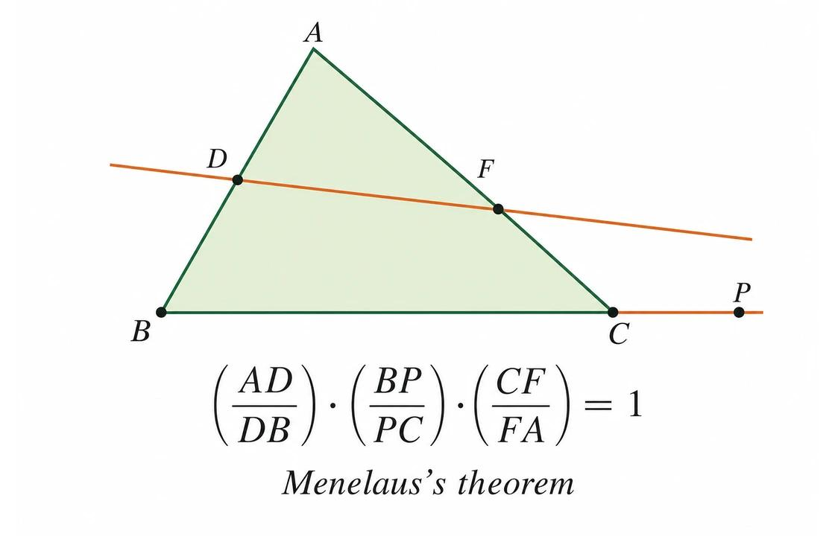
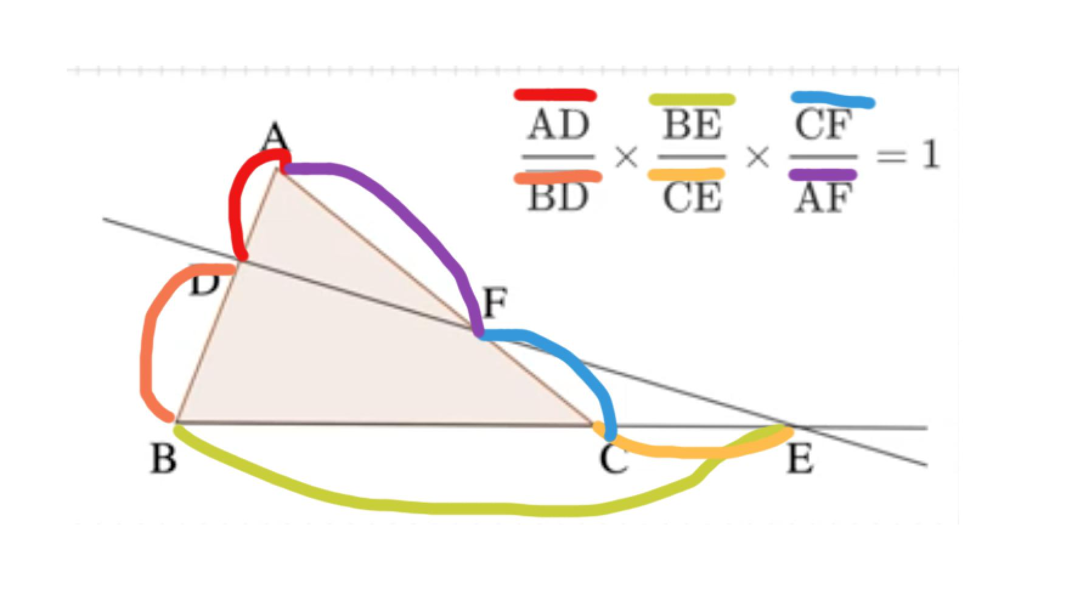
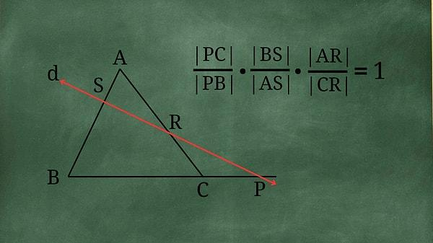

Coordinate Ratio Equality
# Source: AI Source: Provided by: [Data Path: Persons Table -> ID Column: 1, Name_En Column: Motasem Essam] -> From: [ChatGPT] on [7/25/2026]
Coordinates can establish equal ratios.
Suppose:
$$A=\left(0 , 0\right), B=\left(6 , 0\right), C=\left(0 , 3\right).$$
Then:
$$AB=6, AC=3.$$
Therefore:
$$\frac{AB}{AC}=\frac{6}{3}=2.$$
Another triangle might have:
$$DE=10, DF=5.$$
Then:
$$\frac{DE}{DF}=\frac{10}{5}=2.$$
Thus:
$$\boxed{\frac{AB}{AC}=\frac{DE}{DF}}.$$

Algebraic Ratio Equality
# Source: AI Source: Provided by: [Data Path: Persons Table -> ID Column: 1, Name_En Column: Motasem Essam] -> From: [ChatGPT] on [7/25/2026]
Suppose:
$$\frac{2x+4}{x}=\frac{12}{6}.$$
Since:
$$\frac{12}{6}=2,$$
we have:
$$\frac{2x+4}{x}=2.$$
Therefore:
$$2x+4=2x.$$
This produces:
$$4=0,$$
which is impossible.
So there is no valid value of $x$satisfying the equality.
This illustrates an important point: an algebraic ratio equality must actually be checked for consistency and valid denominators.
A Valid Algebraic Example
Let:
$$\frac{x+2}{6}=\frac{8}{12}.$$
Since:
$$\frac{8}{12}=\frac{2}{3},$$
we have:
$$\frac{x+2}{6}=\frac{2}{3}.$$
Cross-multiply:
$$3\left(x+2\right)=12. \\ 3x+6=12. \\ 3x=6. \\ x=2.$$
Therefore:
$$\boxed{x=2}.$$

Ratio Equality and Proportion
# Source: AI Source: Provided by: [Data Path: Persons Table -> ID Column: 1, Name_En Column: Motasem Essam] -> From: [ChatGPT] on [7/25/2026]
An equation of the form:
$$\boxed{\frac{a}{b}=\frac{c}{d}}$$
is called a proportion.
Therefore:
$$\boxed{\text{Ratio Equality}→\text{Proportion}}$$
when two ratios are set equal.
For example:
$$\frac{2}{3}=\frac{4}{6}.$$
The two ratios have the same value.

Cross-Multiplication
# Source: AI Source: Provided by: [Data Path: Persons Table -> ID Column: 1, Name_En Column: Motasem Essam] -> From: [ChatGPT] on [7/25/2026]
For:
$$\frac{a}{b}=\frac{c}{d},$$
where:
$$b≠0, d≠0,$$
we can write:
$$\boxed{ad=bc}.$$
Example
$$\frac{3}{5}=\frac{9}{15}.$$
Cross-multiply:
$$3\left(15\right)=5\left(9\right) \\ 45=45.$$
Therefore the ratios are equal.

Ratio Equality Does Not Mean Length Equality
# Source: AI Source: Provided by: [Data Path: Persons Table -> ID Column: 1, Name_En Column: Motasem Essam] -> From: [ChatGPT] on [7/25/2026]
This distinction is extremely important.
Suppose:
$$\frac{AB}{CD}=\frac{1}{2}.$$
This does not mean:
$$AB=CD.$$
Instead:
$$AB=\frac{1}{2}CD.$$
Example
$$AB=5, CD=10.$$
Then:
$$\frac{AB}{CD}=\frac{5}{10}=\frac{1}{2}.$$
The lengths are different, but their ratio is exactly defined.
Therefore:
$$\boxed{\text{Ratio Equality}≠\text{Length Equality}}$$
in general.

Ratio Equality vs Segment-Length Equality
# Source: AI Source: Provided by: [Data Path: Persons Table -> ID Column: 1, Name_En Column: Motasem Essam] -> From: [ChatGPT] on [7/25/2026]
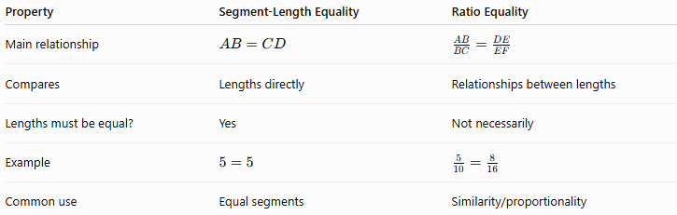
Property | Segment-Length Equality | Ratio Equality
Main relationship | $$AB=CD$$ | $$\frac{AB}{BC}=\frac{DE}{EF}$$
Compares | Lengths directly | Relationships between lengths
Lengths must be equal? | Yes | Not necessarily
Example | $$5=5$$ | $$\frac{5}{10}=\frac{8}{16}$$
Common use | Equal segments | Similarity/proportionality

Ratio Equality vs Similarity
# Source: AI Source: Provided by: [Data Path: Persons Table -> ID Column: 1, Name_En Column: Motasem Essam] -> From: [ChatGPT] on [7/25/2026]
Similarity frequently produces Ratio Equality, but the concepts are not identical.
Ratio Equality
$$\frac{AB}{DE}=\frac{BC}{EF}.$$
Similarity
$$△ABC∼△DEF.$$
Similarity includes both:
- equal corresponding angles;
- proportional corresponding sides.
Thus:
$$\boxed{\text{Similarity}⇒\text{Corresponding Side Ratio Equality}}$$
but a single ratio equality by itself is generally not enough to establish similarity.

Ratio Equality vs Scale Factor
# Source: AI Source: Provided by: [Data Path: Persons Table -> ID Column: 1, Name_En Column: Motasem Essam] -> From: [ChatGPT] on [7/25/2026]
The scale factor is one particular common ratio.
For similar figures:
$$\boxed{k=\frac{\text{corresponding length in image}}{\text{corresponding length in original}}}$$
For example:
$$\frac{12}{6}=\frac{18}{9}=2.$$
Therefore:
$$\boxed{k=2}.$$
Ratio Equality describes the equality of ratios; the scale factor is the common value of corresponding-length ratios.

Important Ratio Relationships
# Source: AI Source: Provided by: [Data Path: Persons Table -> ID Column: 1, Name_En Column: Motasem Essam] -> From: [ChatGPT] on [7/25/2026]
Segment ratios
$$\boxed{\frac{AB}{BC}=\frac{DE}{EF}}$$
Similar triangles
$$\boxed{\frac{AB}{DE}=\frac{BC}{EF}=\frac{AC}{DF}}$$
Angle Bisector Theorem
$$\boxed{\frac{BD}{DC}=\frac{AB}{AC}}$$
Basic Proportionality Theorem
$$\boxed{\frac{AD}{DB}=\frac{AE}{EC}}$$
Area ratio of similar figures
$$\boxed{\frac{A_{2}}{A_{1}}=k^{2}}$$
Perimeter ratio of similar figures
$$\boxed{\frac{P_{2}}{P_{1}}=k}$$
Circle radius/diameter ratio
$$\boxed{\frac{r_{1}}{r_{2}}=\frac{d_{1}}{d_{2}}}$$

Classification Summary
# Source: AI Source: Provided by: [Data Path: Persons Table -> ID Column: 1, Name_En Column: Motasem Essam] -> From: [ChatGPT] on [7/25/2026]
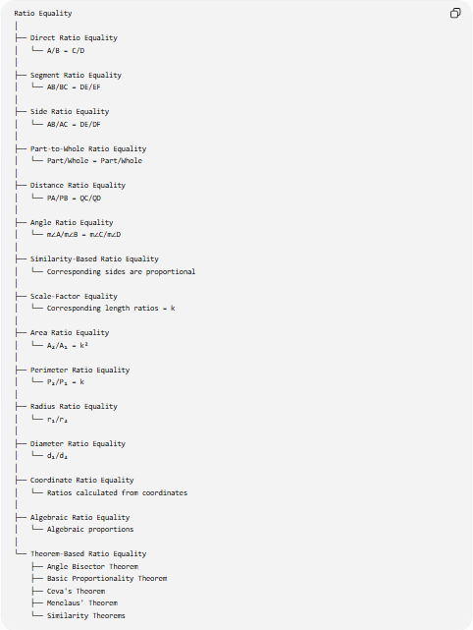
Ratio Equality
│
├── Direct Ratio Equality
│ └── A/B = C/D
│
├── Segment Ratio Equality
│ └── AB/BC = DE/EF
│
├── Side Ratio Equality
│ └── AB/AC = DE/DF
│
├── Part-to-Whole Ratio Equality
│ └── Part/Whole = Part/Whole
│
├── Distance Ratio Equality
│ └── PA/PB = QC/QD
│
├── Angle Ratio Equality
│ └── m∠A/m∠B = m∠C/m∠D
│
├── Similarity-Based Ratio Equality
│ └── Corresponding sides are proportional
│
├── Scale-Factor Equality
│ └── Corresponding length ratios = k
│
├── Area Ratio Equality
│ └── A₂/A₁ = k²
│
├── Perimeter Ratio Equality
│ └── P₂/P₁ = k
│
├── Radius Ratio Equality
│ └── r₁/r₂
│
├── Diameter Ratio Equality
│ └── d₁/d₂
│
├── Coordinate Ratio Equality
│ └── Ratios calculated from coordinates
│
├── Algebraic Ratio Equality
│ └── Algebraic proportions
│
└── Theorem-Based Ratio Equality
├── Angle Bisector Theorem
├── Basic Proportionality Theorem
├── Ceva's Theorem
├── Menelaus' Theorem
└── Similarity Theorems

Relationship to Geometric Equality
# Source: AI Source: Provided by: [Data Path: Persons Table -> ID Column: 1, Name_En Column: Motasem Essam] -> From: [ChatGPT] on [7/25/2026]
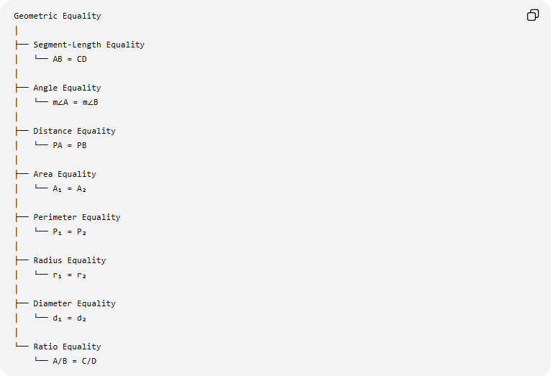
Geometric Equality
│
├── Segment-Length Equality
│ └── AB = CD
│
├── Angle Equality
│ └── m∠A = m∠B
│
├── Distance Equality
│ └── PA = PB
│
├── Area Equality
│ └── A₁ = A₂
│
├── Perimeter Equality
│ └── P₁ = P₂
│
├── Radius Equality
│ └── r₁ = r₂
│
├── Diameter Equality
│ └── d₁ = d₂
│
└── Ratio Equality
└── A/B = C/D
Ratio Equality differs from most of the other equality types because it primarily compares relationships between quantities, rather than simply asserting that two quantities themselves are equal.

Key Points
# Source: AI Source: Provided by: [Data Path: Persons Table -> ID Column: 1, Name_En Column: Motasem Essam] -> From: [ChatGPT] on [7/25/2026]
- Ratio Equality means:
$$\boxed{\frac{A}{B}=\frac{C}{D}}$$
- Equal ratios form a proportion.
- Cross-multiplication gives:
$$\boxed{AD=BC}.$$
- The quantities themselves do not need to be equal.
- Similar figures have equal ratios of corresponding lengths.
- The scale factor is the common ratio between corresponding lengths.
- For similar figures:
$$\boxed{\text{Length ratio}=k} \\ \boxed{\text{Perimeter ratio}=k} \\ \boxed{\text{Area ratio}=k^{2}}.$$
- The Angle Bisector Theorem establishes a geometric ratio equality:
$$\boxed{\frac{BD}{DC}=\frac{AB}{AC}}.$$
- The Basic Proportionality Theorem establishes:
$$\boxed{\frac{AD}{DB}=\frac{AE}{EC}}.$$
- Ceva and Menelaus use products of segment ratios to establish concurrency and collinearity conditions.
- Ratio Equality is closely related to proportionality, similarity, scale factors, and geometric theorems.

Conclusion
# Source: AI Source: Provided by: [Data Path: Persons Table -> ID Column: 1, Name_En Column: Motasem Essam] -> From: [ChatGPT] on [7/25/2026]
Ratio Equality is an exact geometric equality in which two or more ratios have the same value:
$$\boxed{\frac{A}{B}=\frac{C}{D}}.$$
It is fundamental for expressing proportional relationships between segments, sides, distances, angles, radii, diameters, areas, and perimeters.
Its most important geometric applications include:
$$\boxed{\text{Similarity}} \\ \boxed{\text{Proportionality}} \\ \boxed{\text{Scale Factors}} \\ \boxed{\text{Angle Bisector Theorem}} \\ \boxed{\text{Basic Proportionality Theorem}} \\ \boxed{\text{Ceva’s Theorem}} \\ \boxed{\text{Menelaus’ Theorem}}$$
The central idea is:
$$\boxed{\text{Ratio Equality}=\text{Equality of Geometric Relationships}}$$
rather than necessarily equality of the individual geometric quantities themselves.

